1.Cover Page

VAPT Report – Week 3

Name: Vaibhav Tripathi
Role: VAPT Intern
Project: Advanced Exploitation & Web Security Testing

2.Executive Summary

This report presents the findings of a Vulnerability Assessment and Penetration Testing (VAPT) exercise conducted on a controlled lab environment. The objective of this assessment was to identify security vulnerabilities in systems and web applications, exploit them in a safe environment, and provide remediation strategies.

The assessment included advanced exploitation techniques, web application testing using DVWA, post-exploitation activities, and a full VAPT cycle simulation. Multiple vulnerabilities such as SQL Injection, Cross-Site Scripting (XSS), and weak authentication mechanisms were identified.

These vulnerabilities pose significant risks including unauthorized access, data leakage, and system compromise. The report provides detailed analysis along with recommended mitigation strategies to enhance system security.

3.Scope & Objectives

The scope of this assessment included testing a vulnerable environment consisting of Metasploitable2 and DVWA.

Objectives:
- Identify vulnerabilities in systems and web applications
- Perform exploitation using Metasploit and SQLMap
- Understand post-exploitation techniques
- Document findings and provide remediation steps

The testing was conducted in a controlled lab environment for educational purposes only.

4.Methodology (PTES)

The testing methodology followed the Penetration Testing Execution Standard (PTES), which includes:

1. Reconnaissance – Gathering information about the target system
2. Scanning – Identifying open ports and services
3. Exploitation – Using vulnerabilities to gain access
4. Post-Exploitation – Maintaining access and collecting data
5. Reporting – Documenting findings and recommendations

This structured approach ensures comprehensive security testing.

5.Tools Used

The following tools were used during the assessment:

- Kali Linux (Attacking Machine)
- Metasploit Framework (Exploitation)
- SQLMap (SQL Injection automation)
- DVWA (Vulnerable Web App)
- Browser Developer Tools (Manual testing)
- Wireshark (Traffic analysis)

These tools helped in identifying and exploiting vulnerabilities effectively.

6.Advanced Exploitation

Advanced vulnerability exploitation involves identifying, analyzing, and leveraging security weaknesses in systems to gain unauthorized access or execute malicious actions. Unlike basic exploitation, advanced exploitation focuses on chaining multiple vulnerabilities, customizing exploit payloads, and bypassing security controls.

One of the key concepts in advanced exploitation is exploit chaining. This refers to combining multiple vulnerabilities to achieve a more impactful attack. For example, an attacker may first exploit a Cross-Site Scripting (XSS) vulnerability to steal session cookies, then use those credentials to bypass authentication controls and gain administrative access. This multi-stage attack significantly increases the severity of the exploitation.

Another important concept is exploit customization. Many publicly available exploits (such as those in Exploit-DB or Metasploit) are generic and may not work directly in all environments. Therefore, attackers or security testers modify these exploits based on the target system configuration. This includes adjusting payloads, modifying IP addresses, ports, and encoding techniques to ensure successful execution.

Obfuscation techniques are also widely used in advanced exploitation. These techniques help bypass security mechanisms such as Web Application Firewalls (WAFs) and Intrusion Detection Systems (IDS). Common methods include encoding payloads, using alternate syntax, and polymorphic techniques that change the appearance of the exploit without altering its functionality.

During this assessment, the Metasploit Framework was used to perform exploitation on the Metasploitable2 virtual machine. The vsftpd 2.3.4 backdoor vulnerability was identified and exploited. This vulnerability allows attackers to gain shell access to the target system by triggering a malicious backdoor present in the FTP service.

The exploitation process involved selecting the appropriate exploit module, configuring target parameters such as RHOST (target IP) and LHOST (attacker IP), and executing the exploit. Upon successful execution, a reverse shell session was established, providing command-line access to the target system.

This demonstrates how attackers can exploit outdated and vulnerable services to gain unauthorized access. It highlights the importance of regular patch management, service hardening, and continuous monitoring of network services.

In real-world scenarios, advanced exploitation techniques are often used in combination with social engineering, privilege escalation, and lateral movement to fully compromise an organization's infrastructure.

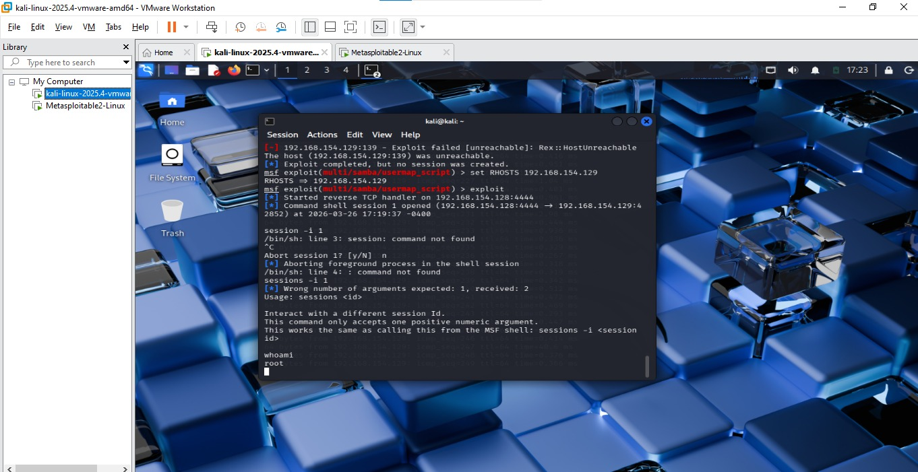

7.Web Application Testing

Web application penetration testing involves identifying and exploiting vulnerabilities in web-based systems to assess their security posture. This process is critical as web applications are one of the most common attack surfaces in modern environments.

During this assessment, the Damn Vulnerable Web Application (DVWA) was used as a test environment to simulate real-world vulnerabilities. The testing focused on identifying issues aligned with the OWASP Top 10, which represents the most critical web application security risks.

One of the primary vulnerabilities identified was SQL Injection. This vulnerability occurs when user input is not properly validated and is directly incorporated into SQL queries. By injecting malicious input such as ‘ OR 1=1 --, it was possible to manipulate the database query and retrieve all records from the database. This demonstrates how attackers can bypass authentication mechanisms and gain access to sensitive data.

To further validate the vulnerability, the SQLMap tool was used to automate the exploitation process. SQLMap successfully detected the injection point, identified the backend database management system (MySQL), and extracted database information including tables and user credentials. Additionally, password hashes were retrieved and cracked using a dictionary-based attack, revealing weak passwords such as “password”, “123456”, and “letmein”.

Another critical vulnerability identified was Cross-Site Scripting (XSS). XSS occurs when user input is not properly sanitized, allowing attackers to inject malicious scripts into web pages.

Two types of XSS were tested:

Reflected XSS:
In this case, the malicious script is immediately executed when the user interacts with the vulnerable input field. A payload such as <script>alert(‘XSS’)</script> was used to demonstrate this vulnerability. The successful execution of the script confirmed that the application does not properly sanitize input.

Stored XSS:
This is a more severe form of XSS where the malicious payload is stored in the application database and executed whenever the page is loaded. This allows attackers to target multiple users and perform persistent attacks such as session hijacking or data theft.

The testing process also included session analysis using browser developer tools. Session cookies such as PHPSESSID were identified, which are used to maintain user sessions. If these cookies are exposed or stolen, attackers can hijack user sessions and gain unauthorized access.

Overall, the web application testing phase demonstrated that the application lacks proper input validation, output encoding, and secure session management practices. These weaknesses significantly increase the risk of exploitation.

This assessment highlights the importance of secure coding practices, regular vulnerability scanning, and adherence to OWASP guidelines to ensure web application security.
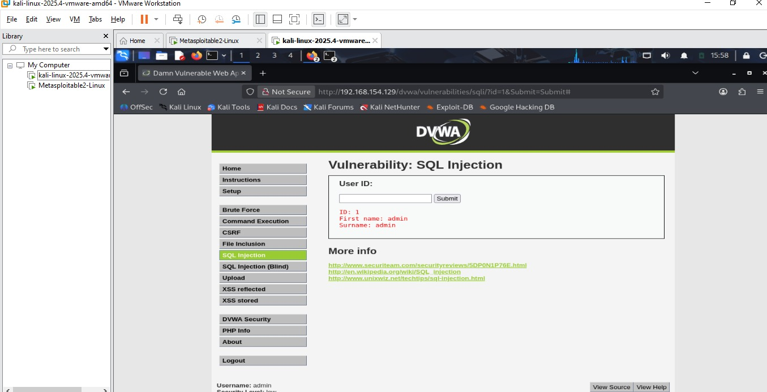
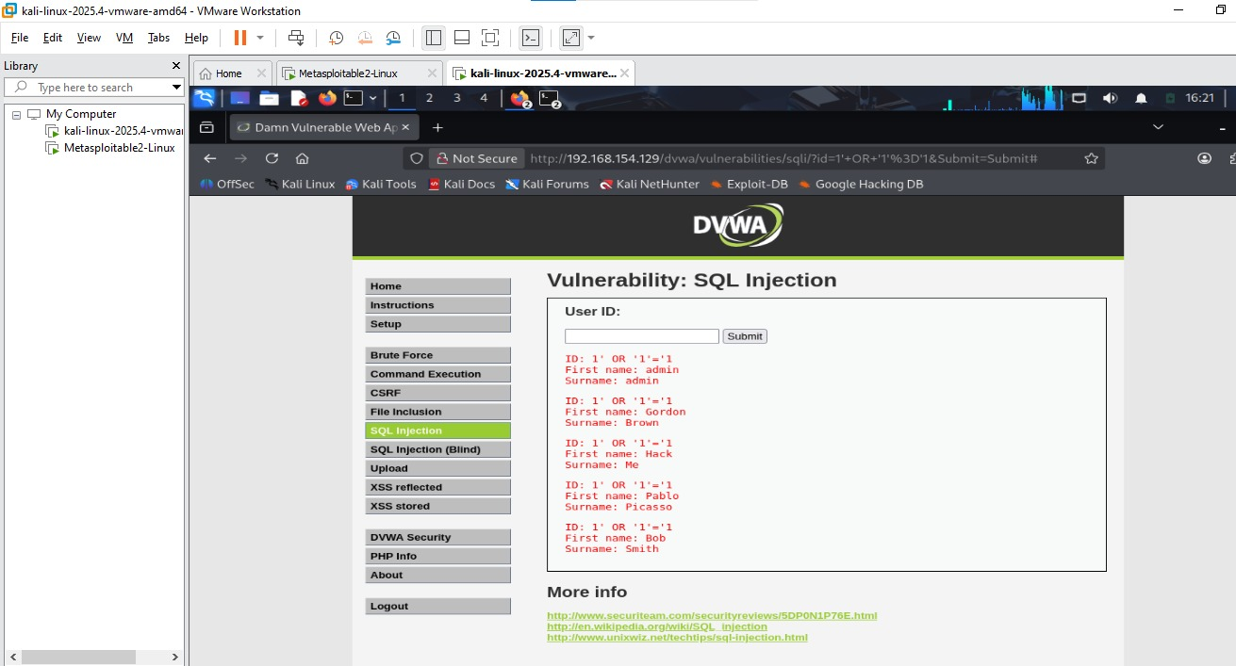

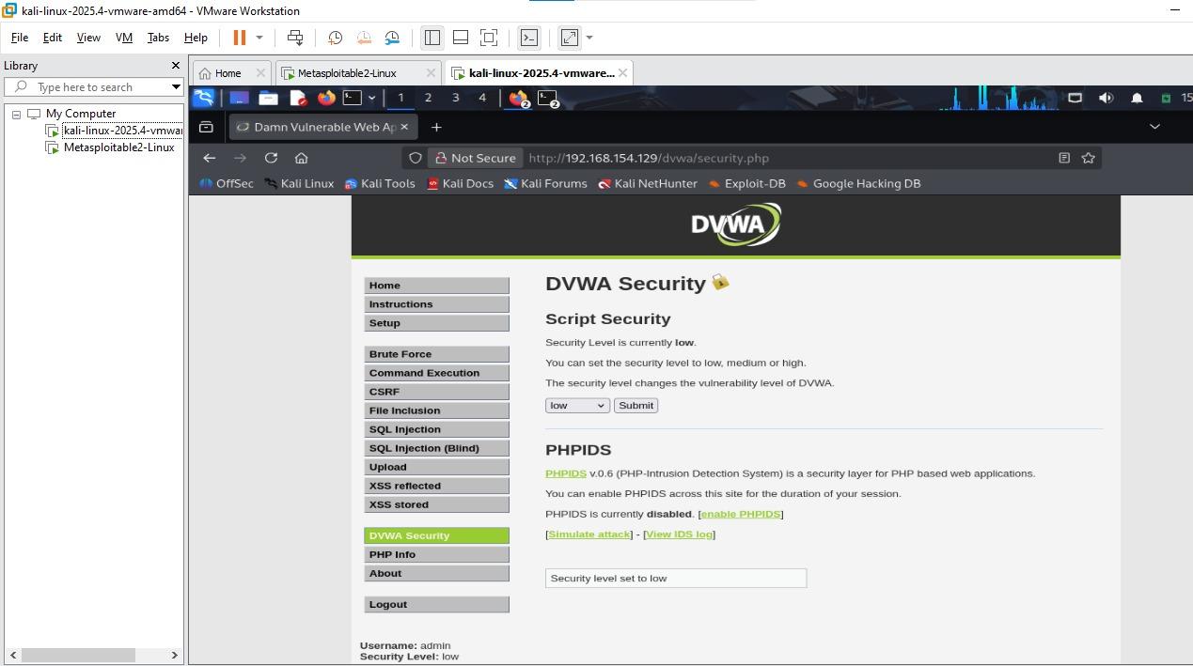

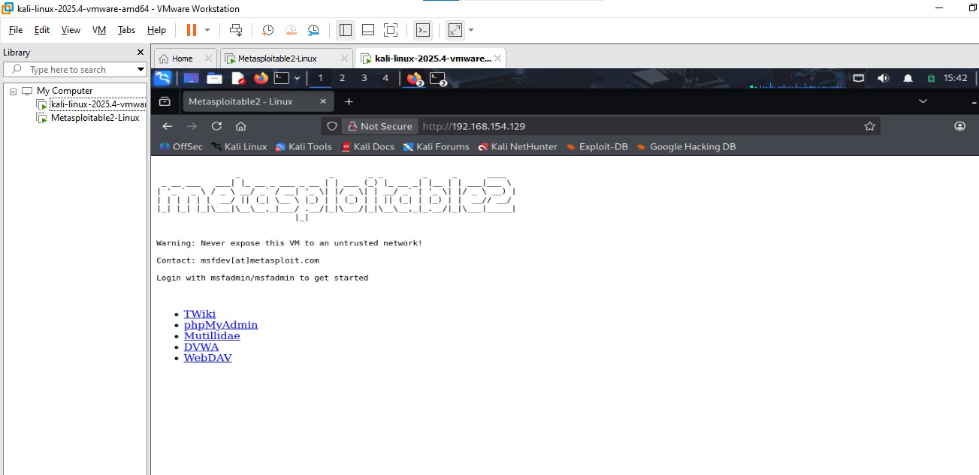

8.Reporting Practice

The findings were documented in a structured format including vulnerability details, severity, and remediation steps.

A clear reporting structure helps both technical and non-technical stakeholders understand risks and take necessary actions.

Proper documentation is a critical part of any penetration testing engagement.

9.Post Exploitation & Evidence

Post-exploitation is a critical phase in penetration testing that begins after successful exploitation of a system. The primary objective of this phase is to assess the extent of compromise, gather sensitive information, and understand the overall impact of the attack.

Once access to the target system was achieved using Metasploit, a command shell session was established. This allowed direct interaction with the compromised system. Various commands were executed to gather system-level information such as user privileges, operating system details, and network configuration.

Commands such as `whoami`, `uname -a`, and `ifconfig` were used to verify access level and system environment. The results confirmed that elevated privileges were obtained, indicating a complete system compromise.

In a real-world scenario, attackers may perform additional actions such as privilege escalation, lateral movement, and persistence. Privilege escalation allows attackers to gain higher-level permissions, while lateral movement enables them to access other systems within the network. Persistence techniques ensure continued access even after system reboots or detection attempts.

Another important aspect of post-exploitation is evidence collection. Evidence helps in understanding the attack path and is crucial for forensic analysis. During this phase, a sample file was created and hashed using the SHA-256 algorithm to demonstrate data integrity verification.

The command used:
echo "test" > file.txt
sha256sum file.txt

The generated hash value acts as a unique fingerprint of the file and ensures that the data has not been altered. This is an important step in maintaining the chain of custody during digital investigations.

Network traffic analysis is also an essential part of evidence collection. Tools like Wireshark can be used to capture and analyze packets to identify suspicious activity, communication patterns, and potential data exfiltration attempts.
Maintaining proper documentation and chain of custody ensures that collected evidence is reliable and can be used in legal or investigative scenarios. This includes recording timestamps, tools used, and actions performed during the assessment.

Overall, the post-exploitation phase highlights the real impact of vulnerabilities, demonstrating how attackers can gain deep access to systems, extract sensitive information, and maintain control over compromised environments.
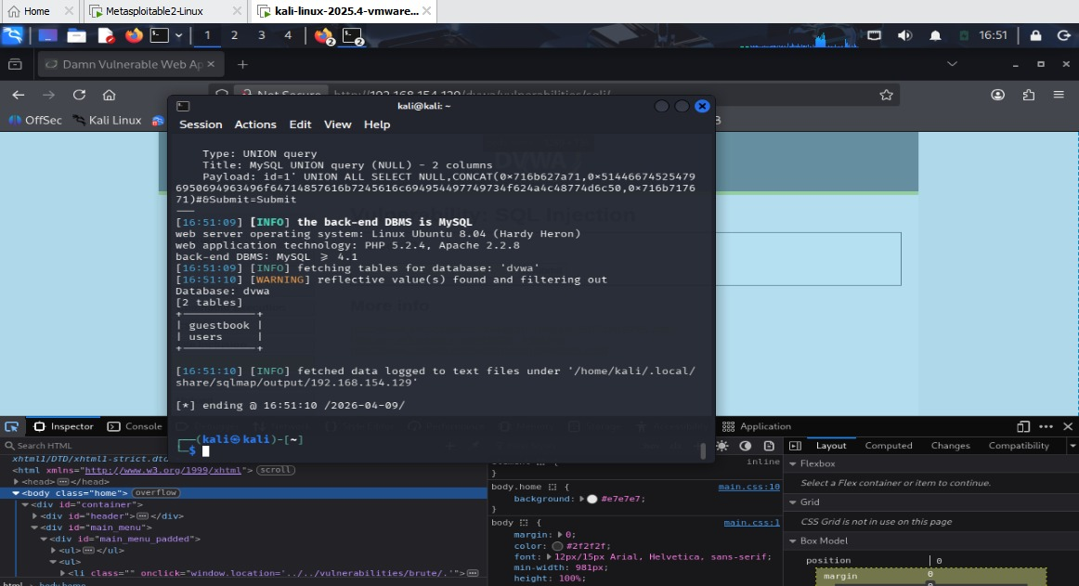
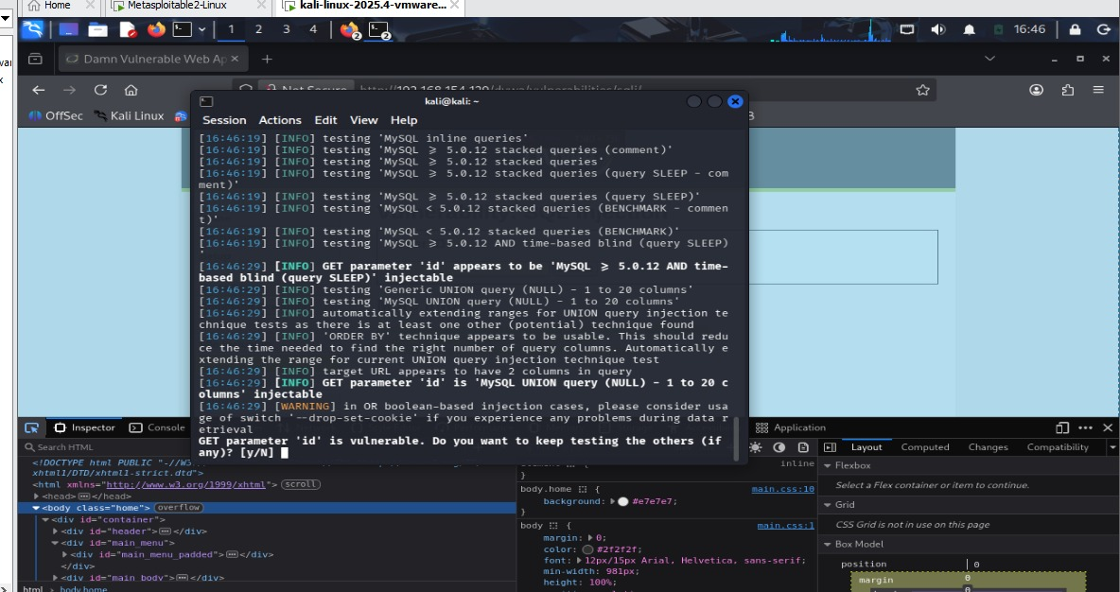
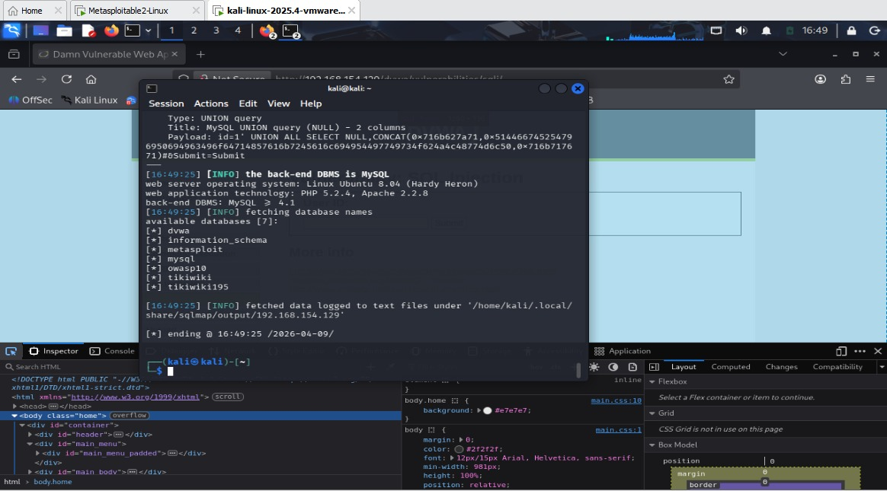

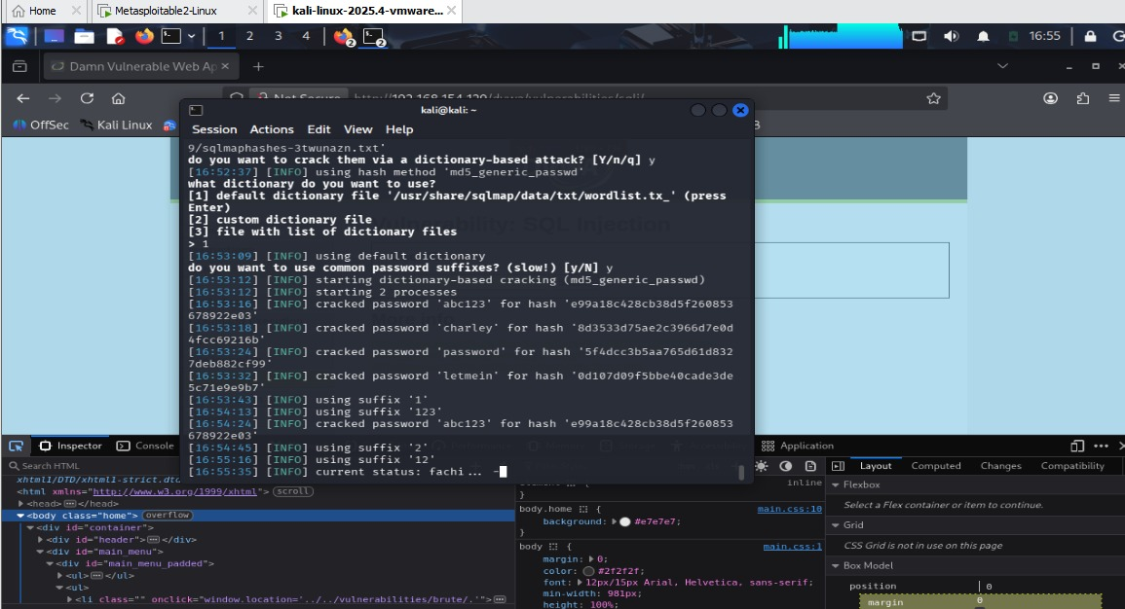
10.Capstone Project

The Capstone Project represents a complete simulation of a real-world Vulnerability Assessment and Penetration Testing (VAPT) engagement. This phase integrates all previously learned concepts, including reconnaissance, scanning, exploitation, post-exploitation, and reporting.

The objective of this project was to perform an end-to-end security assessment on a controlled lab environment and identify critical vulnerabilities that could be exploited by attackers.

---

## Methodology

The assessment followed the Penetration Testing Execution Standard (PTES), which includes the following phases:

1. Reconnaissance:
Initial information gathering was performed to identify the target system and its services. This includes identifying IP addresses, open ports, and running services.

2. Scanning:
Network scanning was conducted using tools like Nmap to detect open ports and service versions. This step helps in identifying potential entry points.

3. Vulnerability Assessment:
The identified services were analyzed for known vulnerabilities. Web applications were tested using DVWA, and automated tools like SQLMap were used to detect injection points.

4. Exploitation:
Exploitation was performed using Metasploit and manual techniques. Vulnerabilities such as SQL Injection and service misconfigurations were successfully exploited to gain system access.

5. Post-Exploitation:
After gaining access, system information was collected, privileges were verified, and evidence was gathered. This phase helped in understanding the full impact of the attack.

6. Reporting:
All findings were documented, including vulnerability details, impact, and remediation recommendations.

---

## Key Findings

The following vulnerabilities were identified during the assessment:

- SQL Injection (Critical): Allowed database extraction and credential access
- Cross-Site Scripting (XSS) (Medium/High): Enabled script execution and session hijacking
- Weak Authentication: Easily guessable passwords were identified
- Vulnerable Services: Outdated services such as vsftpd allowed remote exploitation

---

## Impact Analysis

The identified vulnerabilities can have severe consequences if exploited in a real-world environment. Attackers can:

- Gain unauthorized access to systems
- Extract sensitive data such as user credentials
- Hijack user sessions
- Execute arbitrary commands on the system

This demonstrates a high-risk security posture and highlights the need for immediate remediation.

---

## Remediation Strategies

To mitigate the identified vulnerabilities, the following actions are recommended:

- Implement strong input validation and sanitization
- Use parameterized queries to prevent SQL Injection
- Apply output encoding to mitigate XSS
- Enforce strong password policies
- Regularly update and patch vulnerable services
- Implement network security controls such as firewalls and IDS/IPS
- Conduct regular security assessments

---

## Conclusion

The Capstone Project successfully demonstrated a complete VAPT lifecycle, simulating real-world attack scenarios. The findings highlight critical security weaknesses that must be addressed to protect systems and data.

This project reinforces the importance of proactive security testing and adopting a layered security approach to defend against evolving cyber threats.

11.Risk & Impact Analysis

Risk and impact analysis is a critical component of penetration testing, as it helps determine the severity of identified vulnerabilities and their potential consequences on the organization.

The vulnerabilities identified during this assessment were categorized based on their likelihood of exploitation and the impact they may cause if successfully exploited.

SQL Injection was classified as a critical vulnerability due to its ability to expose sensitive database information. An attacker can retrieve user credentials, modify data, or even execute administrative operations on the database. This can lead to complete data compromise and loss of confidentiality.

Cross-Site Scripting (XSS) was categorized as a medium to high-risk vulnerability depending on the type. Reflected XSS can be used for phishing attacks, while stored XSS poses a greater threat as it affects multiple users and can lead to session hijacking and persistent exploitation.

Weak authentication mechanisms significantly increase the risk of unauthorized access. The presence of easily guessable passwords indicates poor security practices and makes brute-force attacks highly effective.

Vulnerable services such as outdated FTP servers (vsftpd) introduce critical risks by allowing remote exploitation. Attackers can gain shell access and potentially take full control of the system.

The overall risk level of the system is considered HIGH due to the presence of multiple exploitable vulnerabilities that can be chained together for a complete system compromise.

If these vulnerabilities are not addressed, attackers can achieve:
- Unauthorized system access
- Data leakage and manipulation
- Privilege escalation
- Persistent access within the network

This analysis highlights the importance of prioritizing critical vulnerabilities and implementing appropriate security controls to reduce the attack surface.

12.Recommendations

To mitigate the identified vulnerabilities and improve the overall security posture of the system, the following recommendations are provided:

1. Input Validation and Sanitization:
All user inputs should be validated and sanitized to prevent injection attacks. This includes filtering special characters and enforcing strict input rules.

2. Use of Parameterized Queries:
Database queries should be implemented using parameterized statements or prepared statements to prevent SQL Injection vulnerabilities.

3. Output Encoding:
Proper output encoding should be applied to prevent Cross-Site Scripting (XSS) attacks by ensuring that user input is not executed as code.

4. Strong Authentication Mechanisms:
Enforce strong password policies, including minimum length, complexity requirements, and periodic password changes. Multi-factor authentication (MFA) should also be implemented where possible.

5. Regular Patching and Updates:
All software and services should be regularly updated to fix known vulnerabilities. Outdated services must be removed or upgraded immediately.

6. Secure Session Management:
Session IDs should be securely generated and protected. Implement measures such as session expiration, secure cookies, and HTTPS.

7. Network Security Controls:
Deploy firewalls, intrusion detection systems (IDS), and intrusion prevention systems (IPS) to monitor and block malicious traffic.

8. Security Awareness and Training:
Users and developers should be educated about common security risks and best practices to prevent vulnerabilities.

9. Regular Security Assessments:
Conduct periodic vulnerability assessments and penetration testing to identify and fix new vulnerabilities.

Implementing these recommendations will significantly reduce the risk of attacks and enhance the overall security of the system.

13.Conclusion

The VAPT assessment revealed multiple critical vulnerabilities in the system and web application.

These vulnerabilities can be exploited by attackers to gain unauthorized access and compromise sensitive data.

Proper security practices, regular testing, and timely patching are essential to protect systems from such threats.

